

# Assignment 1 Keyword Research and Page Optimization

### Learning Outcomes

1. Basic understanding of search engine optimization
2. Familiarity with industry standard SEO tools
3. Basic keyword analysis
4. Page optimization and technical SEO techniques

### Submission Instructions

To get credit, students will download, complete and submit this completed document before the posted due date posted in Canvas.

# Keyword Research

Keyword research is an important first step in any SEO strategy. In order to get people to your site, you must first know which words they are already using to find you. Oftentimes, the terms people are actually using may not be exactly what you expect. For example, let's imagine we own a small craft brewery. This brewery makes many different styles of beer but their light beers seem to be best sellers. The Brewery has a website that is optimized for the terms “light beer” or “lite beer”. We think these are good terms because they encompass a variety of products and are in line with popularity. But when we dig a little deeper, we realize that using these terms may be hurting our search results instead of helping!

When we search for “light beer” or “lite beer” we are presented with links to the websites of Miller, Coors and Budweiser. As much as I would like my small brewery to compete with these mega-brewers, it is just not realistic. In fact, my website does not show up on the first or second page when searching for these terms. How can this be? I thought my site was “optimized”?

Well, the truth of the matter is that my site is optimized, just not for the right terms. More specific terms like “blonde ale” or “new york pale ale” or “best pale ale in the northeast” would be much better. First, when I test these terms the results seem to be much more in line with my actual business competitors. Also, someone who is searching for a very specific type of beer that I offer is typically a better qualified lead than someone simply looking for a generic light beer.

Now that we know the truth about how people find us, we need to rethink the content, markup and possibly the structure of our website to **optimize** it for these new search terms.

## Product of Service

For the purposes of this assignment, you will be analyzing the product or service you have chosen for the semester. Pay close attention to the terms they currently use to describe their product or service. Are there specific terms that seem to be used repeatedly? Can you start to guess what users might type into a search engine (Google) to find this product or service?

## Brainstorming

Believe it or not, most keyword research starts with a series of guesses. Marketers and SEO professionals simply take educated guesses on what terms customers might use to find their product or service. This may seem a bit unscientific — and it is — but this stage of the research process is just about creating a starting point. We will refine this list later.

## **Task #1**

Using the space below, create a list of words or phrases that a Google user might use to find your product or service. List at least **20 terms or phrases** to start. Don’t limit yourself at this point, put down any terms or phrases you think might be relevant. You may include [branded and non-branded terms](https://searchenginewatch.com/sew/how-to/2405547/brand-vs-non-brand-measurement-is-key).

1.Free People Coat

2. Free People Jacket

3. Hit The Slope Jacket

4. Fleece Jacket

5. Best Free People Jackets

6. Warm crewneck

7. Good Quality Fleece

8. Best Fleece Jacket

9. Best Free People Items

10. Colorful Fleece

11. Warm Winter Pullover

12. Free People Pullover

13. Best Pullover

14. Best Quality Pullover

15. Free People

16. Free People Winter Collection

17. Colorful Coat

18. Fleece Jacket women

19. Free People Crewneck

20. Long-lasting Fleece

Now that we have our basic keyword list, let's add some variations. We do this by adding “stems” to our list of brainstormed terms. Stems are words like “How do I _______” or “Where can I ________” that are added to the beginning or ending of the original keyword or phrase. These stems can take a very generic term and make it much more specific. These stems added to the keyword list above create what is known as “long tail” keywords. [Google suggests a feature that can](https://www.searchenginejournal.com/beginners-guide-google-suggest-marketers-seo/73269/) help with this process.

## Task #2

See if you **can come up with at least fifteen long tail keywords** in the space below that will work to attract the right customers to your company's website.

1. Where to find the best fleece?

2. Where to find the best fleece for women?

3. Best quality warm winter pullover

4. What are Free People’s best coats?

5. Fleeces warm enough to ski in

6. Where to find stylish fleeces?

7. Where to find practical and stylish fleeces?

8. Warmest fleeces for the winter

9. Where to find colorful ski outfits?

10. Where to find the best winter fleece?

11. High-quality winter fleece jacket

12. Where to find Free People’s Hit The Slopes Collection?

13. Where to find a warm fleece?

14. Where to find a high-quality fleece?

15. Does Free People sell fleeces?

## Analysis

Now we are going to analyze our keyword list to see how close we actually are to keywords that people are actually using for search. There are many tools out there that can help us research and plan keywords for any particular web page. [Google’s AdWords Keyword Planner](https://adwords.google.com/KeywordPlanner) and the [free version of WordTracker](https://freekeywords.wordtracker.com/sign_in/) are popular choices. You may also choose to use the [keyword generator tool from AHREFS](https://ahrefs.com/keyword-generator).

### Suggested Keywords

To get started access the keyword suggestion tool of choice. If using the [Google AdWords Keyword Planner Tool](https://adwords.google.com/KeywordPlanner) you will need a Gmail account, and you will need to sign up for Google AdWords. AdWords is Google’s online advertising product for placing pay-per-click ads and display ads. We will use this tool again later in the semester. Once you have access to the Keyword Planning Tool, click the “Search for new keyword and ad group ideas” option.

**NOTE: You do not have to pay for this service.** [**Read this article to start using the keyword planner tool without entering any credit card information into Google Adwords**](https://ahrefs.com/blog/google-keyword-planner/)**.**  If you are having trouble gaining access to the keyword planner tool contact me for help.

To continue researching keyword ideas choose the “find new keywords” option.

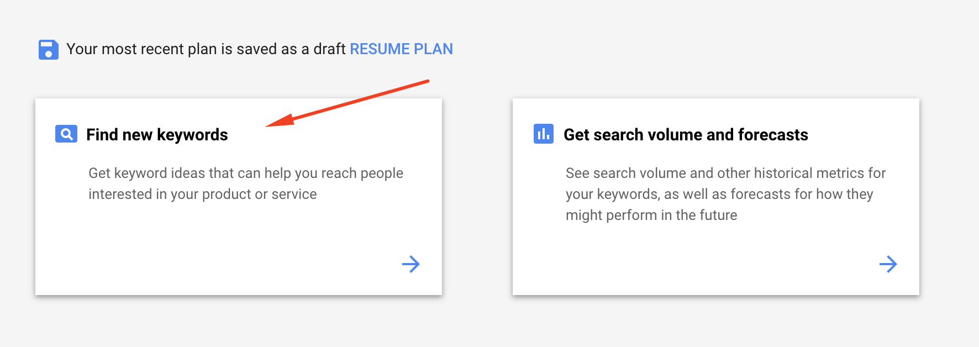

Enter a few “seed” keywords that describe your product or service and/or a url that describes it. Then click “get started”.

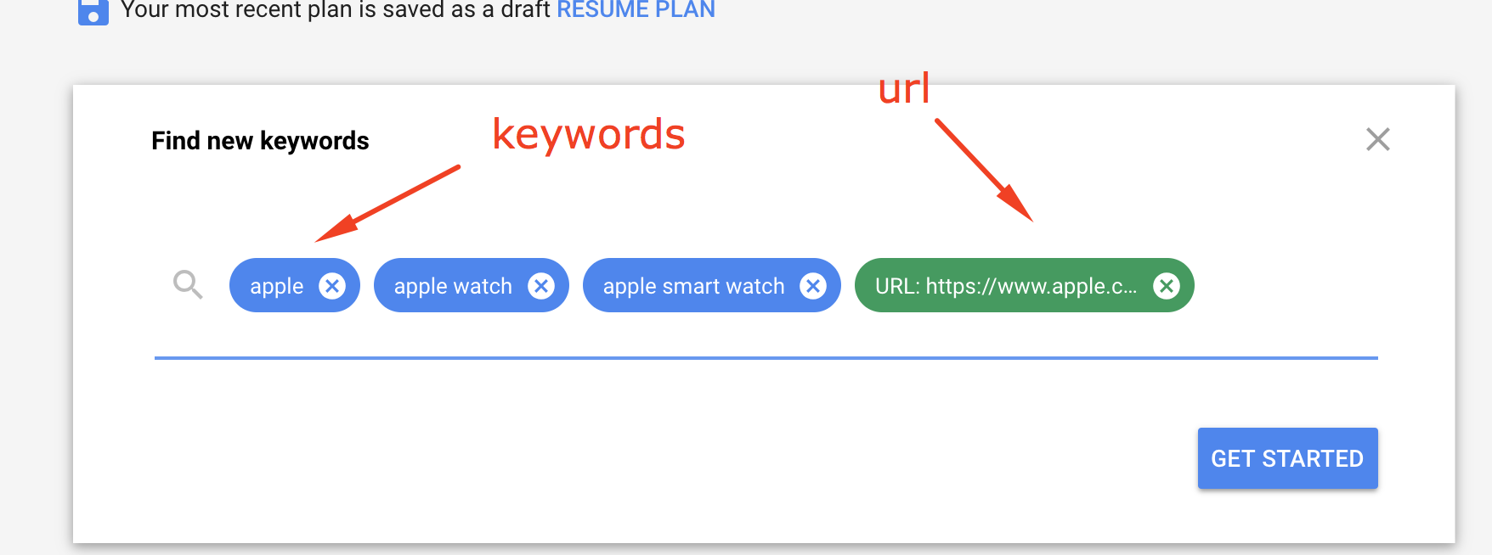

You should be presented with around 1000 - 1200 keyword ideas, a vague number of average monthly searches, an indication of how competitive this keyword is and some suggested bids. This information should give you some indication of the quality of the keyword. If you would like to dig a little deeper, [this article goes into detail about how to get the most out of the keyword planner tool](https://ahrefs.com/blog/google-keyword-planner/).

Take a look at the suggestion the Keyword Planner tool has provided. Are they in line with your original brainstorm list? Are there any surprises? Go back and change your “seed” keywords and/or URL. See how it affects the suggested keyword list.

Click the checkbox next to keywords you think you may want to rank for and add them to your keyword plan. I would suggest you add about 15-20 keywords to your plan.

Task #3

Take a screenshot of **your keyword plan or the keyword research you performed in any keyword research tool and**  paste in the space below.

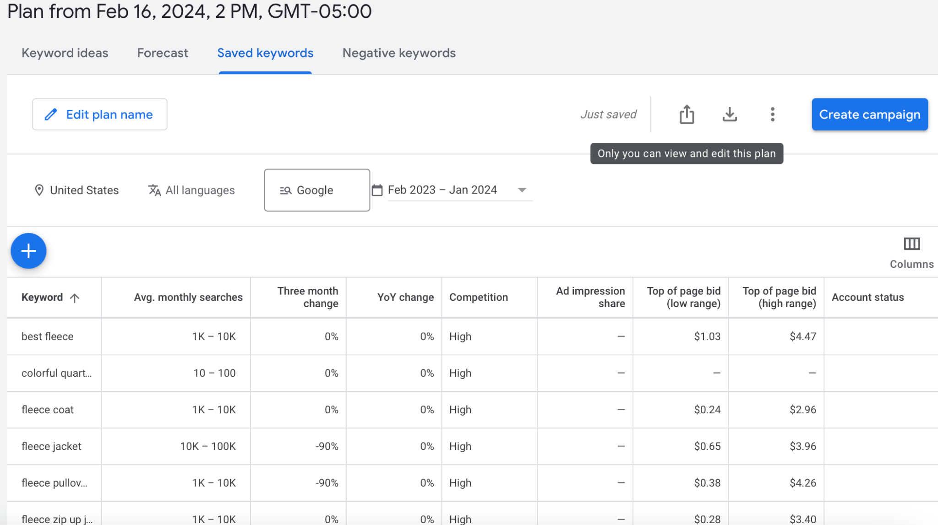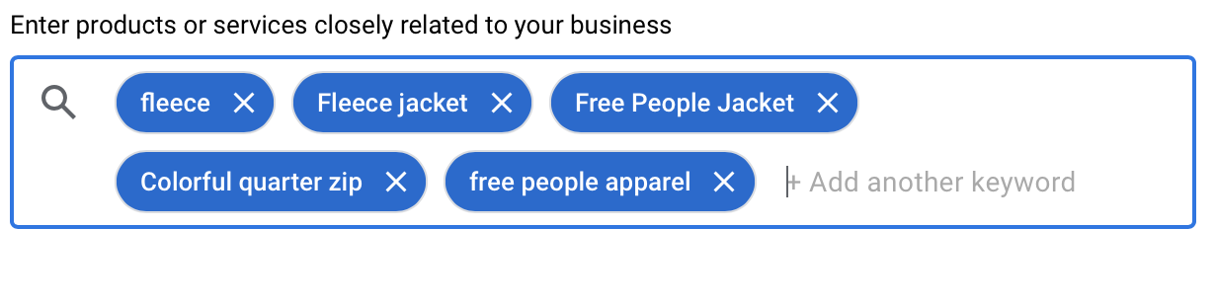

After looking at all the suggested keywords, what have you learned? How will you make adjustments?

Through exploring Google Ads I got a lot of insight both into the keyword selection process as well as the optimal keywords for the Hit The Slopes Free People Fleece. First, I really learned the power of Patagonia when it comes to outdoor apparel. Anytime I would input suggested keywords including any outdoor related words such as fleece, jacket, and outdoor apparel almost all of the recommended keywords included Patagonia. I also learned the power of variation when choosing keywords. The suggestions from Google Ads really opened my eyes to how many different ways you can search for a fleece jacket, some of which I would have never thought of. Looking forward, I plan to use the suggested keywords and also work to find variety in my keywords based on the competition level, impressions, and suggested CPC. Starting from scratch, I think adding variation to my keywords is crucial so that I can learn what works and what doesn’t and also so I can find that sweet spot of the highest return on investment with the lowest ad spend. I want to ensure that I am finding customers who are ready to make a conversion when they are searching on Google.

### Relevance

Knowing what terms users are searching is one thing, but making sure those terms accurately describe your product or service is another. Take a look at the suggested keywords from the previous steps. Do they accurately describe your product or service? Think to yourself, “When the user searches this query, what are they looking for? What do they want? If they find my site, will it meet their needs?” If your results are like mine, most suggested terms should be fairly relevant, however there are usually a few terms that are way off base. That is ok, just take note of the terms you think are bad. We will use this to help refine our list later.

### Search Volume

Our next step is to analyze search volume and competition for the suggested terms. After adding keywords to your plan, click the “Keywords” on the right hand navigation as indicated in the screenshot below. This view will give you additional keyword volume information like number of expected clicks and impressions.

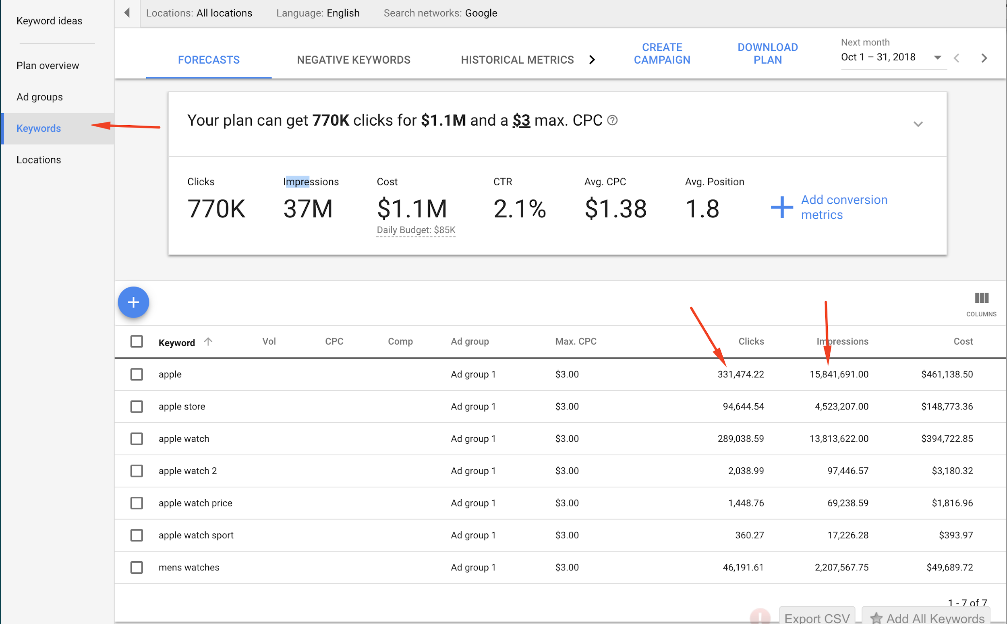  
  
We are going to use these metrics to refine our keyword list even further, but here is where things get a little tricky. We don’t necessarily want to choose all the terms that have the highest average monthly searches, impressions and clicks. We may want to include more specific long tail terms that have a high likelihood of getting people to your site. Also, we want to ensure these keywords are relevant to our product or service.

Take a look at the example below.   
   
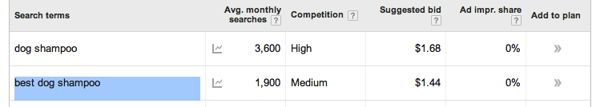  
The term “dog shampoo” has 3600 monthly searches but high competition. The search phrase “best dog shampoo” has 1900 average monthly searches but lower competition.

## Task #4

In the space below, tell me **which term in the above example** do you think would be more effective in terms of getting users to your site and why?

I think that “best dog shampoo” would be more effective in terms of getting users to your site because it is not as competitive of a keyword, therefore there is a higher chance that you will achieve a higher ad ranking for a lower cost per click. While I understand “dog shampoo” gets more average monthly searches, with a higher suggested bid and competition, there is a lower chance that you will get a high ad ranking.

## Task # 5

Do your best to narrow down your terms based on what we have learned so far. Get rid of terms that you think are not very relevant to your product or service and add good suggested terms from your keyword research. You may also want to remove terms that do not get enough search volume.

At this point you should try to get your list down to about **ten to fifteen high quality terms**.  **Paste those terms in the space below.** Remember, there is no right answer here, SEO is an iterative process of elimination.

1. women’s fleece
2. free people hit the slopes jacket
3. quarter zip fleece
4. hit the slopes fleece jacket
5. half zip fleece
6. women’s fleece jacket
7. free people fleece
8. fleece coat
9. colorful quarter zip
10. best women’s fleece
11. walking fleece
12. women’s outdoor fleece
13. free people movement
14. fp movement
15. stylish fleece jacket

Now it is time to get tough and take a good look at our competition. This phase of the keyword research process is about making sure we are competing in the right space, using the right terms. We want to make sure that the search results for any targeted terms are right for our product.

To start our competition analysis, select one of your targeted terms from your refined list. In the example below I chose to use “best dog shampoo” as my selected term. Type the term or phrase you selected into a normal Google search box and take a look at the results. Are these your competitors? If you think they are, take another look…are they really?  
  
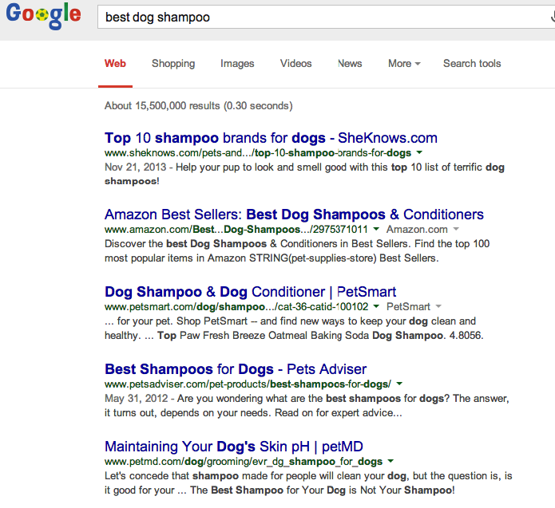

In the example above, you can see that this term yields results that are not exactly direct competitors. The results for this term are mostly how-to blog articles and large online retailer sites. For this particular website my direct competitors would be actual shampoo manufacturers, not retailers and bloggers.

Let's try another term. This time I typed “all natural dog shampoo” into Google. If you look at the results for this term you can see that most of the results are actual shampoo manufacturers, not retailers. These results also seem similar to my product in terms of the size of the company as well. This is good! We are getting closer!  
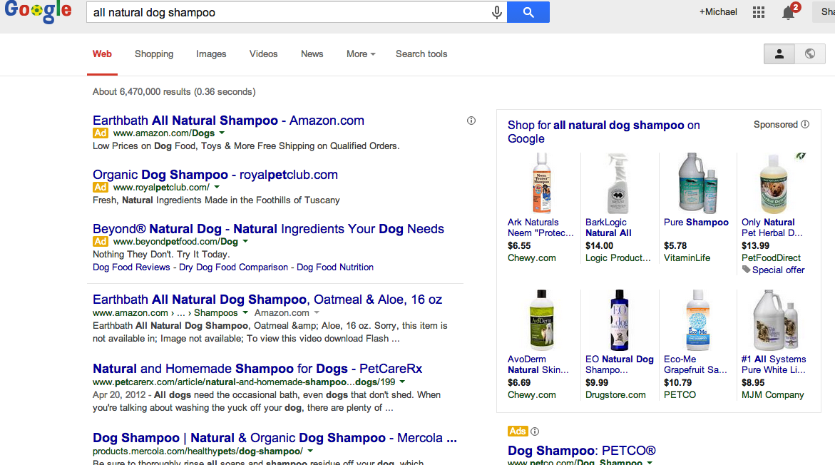

## Task #6

Run this same competitive analysis test on all ten of your targeted keywords. See if you can narrow down the list even more. Try to **narrow your list down to the five most relevant**, highly searched, least competitive and most accurately competitive terms. **Paste your terms in the space below**.

1. best women’s fleece
2. free people hit the slopes jacket
3. colorful quarter zip
4. stylish fleece jacket
5. quarter zip fleece

# Page Optimization

Selecting the best possible terms for your product or service is just half the battle. Once we have terms we would like to target, we now need to add those terms to our web content. After all, if we want people to find our product page by searching “all natural dog shampoo” we better make sure that the words “all natural dog shampoo” actually exists on our webpage!

There are many, many factors that affect how “optimized” a page is for any particular term. [This article written by SEOMoz](http://moz.com/beginners-guide-to-seo/basics-of-search-engine-friendly-design-and-development) does a good job explaining the basics of what search engines like, and what they don’t like. Read through it to get a better understanding of what it takes to optimize a page.

## Task #7

After you have read through this article, take some time to explain what changes you would make to your product or service’s website. These changes should be based on the keyword research you did earlier and the information found in the Moz article and what we have learned in class. In a list of bullet points **tell me what changes you will make to your website and why**. I expect you to cite **at least 6 page optimizations** in your answer.

1. **Incorporate target keywords**: The first change I will make is pretty simple and will involve seamlessly incorporating my target keywords throughout my website. As discussed in the article, ensuring that you are connecting what the consumer wants to what you are showing on your website is crucial. I plan to do this without overstuffing my website with keywords and placing them in irrelevant places.

* <p class="text">Discover an effortlessly slouchy, stylish fleece jacket for the slopes as well as everyday life. Timeless, high-quality, fleeces for <strong>IT </strong></strong>girls.</p><!--Optimization: Includes my target keywords-->

1. **Anchor text:** I also plan to add anchor text to all of my links so the user better understands the use for the link and also so that the search engine receives signals about the content of the destination page.

* <pre><p class="text1"><a href="https://www.freepeople.com/fpmovement/fp-movement-hit-the-slopes-collection/?q=hit%20the%20slopes" target="blank">SHOP THE COLLECTION</a> <!--Optimization: Anchor Text-->

1. **Alt Tags**: I will add detailed alt tags to all of my images to ensure that my website is accessible to all users, including those that are visually impaired and need to use screen readers.

* <div><img src="../IST321/images2/48781546_011_f.webp" width= "300" alt="A model playing tennis in the sun in a Free People jacket"></div><!--Optimization: Alt Text-->

1. **target=”blank”:** I also added target=”blank” code to all of my external links to make sure that a new tab is opened when clicking on the link. This is just a minor improvement that I think makes a huge difference as you will not lose your spot on the original page.

* <pre><p class="text2"><a href="https://www.freepeople.com/fpmovement/fp-movement-hit-the-slopes-collection/?q=hit%20the%20slopes" target="blank">SHOP THE COLLECTION</a> <!--Optimization: Target Blank Tag—->

1. **Supporting media:** I included supporting media, such as images and widgets, to help better describe the content and compliment the words on the page.

* <div><img src="../IST321/images2/48781546_418_c.webp" width= "300" alt="A model wearing a white fleece jacket in the mountains"></div><!--Optimization: Supporting images-->

1. **Meta description:** Lately, as discussed in class, I added a meta description to my code to help describe the contents of the page that I created. I used the tag name=”description content=”page description” in the <head> </head> of my website.

* <meta name="description" content="This webpage features images and information about the Free People Hit The Slopes Collection and Fleece."><!--Optimization: meta description tag -->

## Task #8

Now that you have a plan, go in and make the changes you have outlined above to your website. Please be sure to p**lace a comment in your HTML code where you have made a change.** Once complete, please [compress the entire website folder structure to a .zip file](https://video.syr.edu/media/t/1_y72oeijl) and submit to blackboard along with this completed assignment document.

# Link Building

## Task #9

Another important tactic in a solid SEO strategy is link building. Gaining links from reputable sources with high domain and page authorities is a difficult task. T**ake a minute to think through where you might focus your link building efforts for this particular product. What sites, blogs or directories might you reach out to? What link building tactics would you use and why? Please write a few paragraphs in the space below explaining your strategy**

When looking at building my link strategy for my product I would focus on three main areas: fashion blogs, influencers/social media, and third-party selling sites. Starting off with fashion blogs, I would plan to reach out to extremely reputable blogs and either work with them to add sponsored sections to their articles with links or ask them to review the products and include links. For example, I would work to find ways to be involved in articles like this [one](https://www.vogue.co.uk/fashion/gallery/fleeces-for-women)by Vogue that detailed 14 of the most fashionable fleeces for the winter. I believe that these articles and review blogs align extremely well with the Free People target customer as they mostly target millennials that are interested in fashion. Similarly, this article is professional and well-written by a credible source.

Next, I would focus a lot of my time and effort on social media and more specifically influencer marketing. With social media continuing to play a large role in facilitating customers to make purchases, I would direct a lot of my attention to ensuring Free People’s social media is up to par. I would work to identify key influencers to support the Hit The Slopes Collection and ensure that they are linking directly to the website whenever possible. Whether that be on Instagram, Tik Tok, or Twitter I would work to build out many links by reputable influencers on these reputable sites. Similarly, I would also work to make sure that influencers are building out their Linktree hubs and including many of the products in their LinkTree. This is a direct way for consumers to see a piece of clothing that they like on an influencer, go to their bio, and then directly to the website or the product. Also, along the lines of social media, I would set aside a portion of my marketing budget to market on Pinterest. Pinterest is a social media site that allows users to discover new products through pictures that directly link to the product itself or show similar options. This social media site is extremely credible, useful in finding new clothing, and aligns well with Free People’s target customer.

Lastly, I would look into getting third-party retailers, like Revolve to sell Free People’s products. While I realize that Revolve will not be directly providing consumers with a link to the product, they will be selling the product and therefore potentially providing traffic to the site. I know personally that when I shop on Revolve and see an article of clothing that I like from a brand, I immediately run to that brand's site to check out the product itself as well as additional pieces that I might like. Again, while I realize that this is not a direct link building strategy and that there will not be a direct link to the product, I wanted to mention it as I believe that it could be extremely beneficial in directing traffic to the Free People site as well as broadening Free People's customer base.